Fr. Cole Kennett Mrs. Ashley Rockey
Superintendent Principal

PRESCHOOL & PREKINDERGARTEN
HANDBOOK
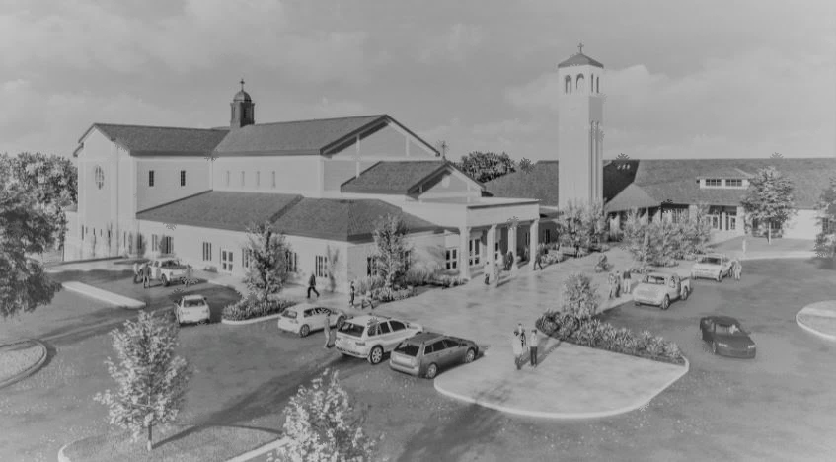
2026-2027
Saint Michael the Archangel, pray for us!

Table of Contents
Introduction and Welcome 4
Mission Statement 4
Curriculum 4
Student Age Requirements and Social-Emotional Skills 5
Age Requirement: 5
Social-Emotional Development: 5
Self-Care and Independence: 5
Enrollment, Waitlist, and Withdrawing Policies 5
Arrival and Dismissal Procedures 5
Arrival 5
Dismissal 7
Sample Daily Schedule 8
Meals, Snacks, Specials Classroom Celebrations 8
Cold Lunch 8
Hot Lunch 8
Snack 8
Classroom parties 9
Valentine’s Day 9
Birthdays 9
Sick Days and Schedule Interruptions 9
Attendance 9
Absence 9
Tardiness 9
Repeated Absences and Tardies 9
Leaving School Grounds 10
Extended Daycare Morning (EDC-AM) 10
Extended Daycare Afternoon (EDC-PM) 10
Doctor and Dental Appointments 10
Vacations 10
Field Trips 10
Behavior Expectations and Discipline 10
Behavior Expectations 11
Behavior Support Procedure 11
Zero Tolerance for Physical Violence 11
Health and Safety Regulations 11
Health Records 11
Immunization Records 11
Physical Exams 12
Dental Exams 12
Health Screening 12
Illnesses 12
Medication 12
Injury/Accidents 13
Health Conditions and Special Medical Needs 13
Lice 14
School Safety and Security 14
Child-to-Staff Ratio 14
Entrances and Exits 14
Safety Procedures/Drills 14
Fire Procedure 14
Tornado Procedure 15
Hold 15
Secure 15
Lock Down Procedures 15
Evacuate 15
Reunification 15
Parent Directives in Emergency Situations 15
BE PREPARED FOR A SCHOOL EMERGENCY 15
IN CASE OF A SCHOOL EMERGENCY 15
FOLLOWING AN EMERGENCY 15
Child Abuse or Neglect 16
Asbestos Hazard Emergency Response Act 16
Emergency Classroom Communication 16
School Family Communication and Involvement 16
Parent-Teacher Meetings 16
What to Expect at a Parent-Teacher Conference 16
Routine Communication 16
Family Involvement Opportunities 16
Visiting During School Hours 17
Contacting Your Child’s Teacher 17
Tuition, Fees, and Billing Policies 17
Tuition 17
Additional Fees & Payment Information 17
Tuition Payment Options 17
Required Documents 17
Acknowledgment and signature 18

St. Michael Catholic School Preschool Handbook

Introduction and Welcome
Welcome to the wonderful world of preschool at St. Michael Catholic School! We are thrilled to have your child join us on this exciting journey of growth, learning, and faith. At St. Michael’s, we are committed to providing a safe, nurturing, and enriching environment where your child will not only learn foundational academic skills but also grow in the love of Christ and the values of our Catholic faith.
Our mission, "Courageously advance the Gospel of Jesus Christ and the work of His Church," is at the heart of everything we do. Through a mix of engaging activities, creative play, and meaningful interactions, your child will experience the joy of learning and discover their unique gifts.
As partners in your child's development, we look forward to working alongside you in helping them succeed, lead with kindness, serve others, and be a disciple of Christ. We are here to support both you and your child every step of the way.
This handbook provides important information about the preschool program, our policies, and the daily activities that make St. Michael’s a special place for your child. We encourage you to read through it carefully and keep it as a reference throughout the year.
Thank you for entrusting us with your child’s early education. We are honored to be part of their journey, and we look forward to a fantastic year together!

Mission Statement
The Saint Michael Catholic School family is a Christ-centered community dedicated to the development of the spiritual formation, academic excellence, and stewardship within the framework of the Gospel and the Tradition of the Catholic Church.
Our mission comes from the Great Commission that Jesus came to each of us to make disciples of all people. Our defining characteristics at St. Michael Catholic School are to be:
- Proudly Catholic
- Excellent in Academics
- Accessible to All
- Sustainable for the Future

Curriculum
God Made Everything - Loyola Press
- Preschool – God Made Me
- PreKindergarten – God Made the World
Heggerty – PreKindergarten
- Phonemic Awareness
Second Step – Committee for Children
- Social Emotional Learning
Weekly Thematic Units

Student Age Requirements and Social-Emotional Skills
At St. Michael Catholic School, we believe that preschool and prekindergarten are important times for your child to develop both academically and socially. In order to ensure a successful experience, we have established the following guidelines:
Age Requirement:
Children must be 3 years old by July 31 in order to be eligible for enrollment in our preschool program. This helps ensure that all students are developmentally ready for the activities and learning experiences we provide.
Social-Emotional Development:
We encourage all preschool students to work on building their social and emotional skills. This includes learning how to interact with peers, follow directions, share, and express emotions appropriately. Developing these skills is essential for a positive and successful preschool experience.
Self-Care and Independence:
Children should be able to independently take care of their personal needs, including using the bathroom. This means that students need to be fully potty trained and able to wipe themselves. Individualized plans may be developed if a student has frequent accidents. We also ask that all children come to school with an extra set of clothes in their backpack in case of an accident. Additionally, students should be able to dress themselves independently, including putting on their shoes and jackets. Please note- no pull ups are allowed and all children are asked to wear underwear during the school day.
These expectations help your child gain confidence and foster their independence in a supportive and safe environment.

Enrollment, Waitlist, and Withdrawing Policies
The pre-enrollment process begins in November and follows the priorities listed below. Pre-enrollment is required for students entering Preschool and PreKindergarten. The following is the policy on prioritization of enrolling children into the St. Michael Preschool and PreKindergarten programs:
Children who have siblings established at St. Michael School and are parishioners have first priority.
Children who are from a registered St. Michael Parish family are considered next for enrollment placement on a first come first serve basis.
Followed by Catholic families from other parishes who have received permission to enroll at St. Michael School.
Followed by Non-Catholic families who desire a Catholic education at St. Michael School.

Arrival and Dismissal Procedures

Arrival
Parents/guardians will be responsible for completing an arrival/dismissal plan via PowerSchool at the beginning of each school year or when a child enrolls. This plan will state how each parent/guardian has planned for their child to arrive and leave school each day. If the parent/guardian changes the plan, the form must be resubmitted with the updated information.
Students may arrive at school starting at 7:45 a.m. Supervision is not provided before that time. All traffic must approach the east entrance to St. Michael from the north (reference maps below). All traffic will enter using the east driveway ramp. The drop-off line of cars will route itself on the perimeter of the parking lots. Follow the orange traffic cones once in the lot, which will guide you to the drop off zone.
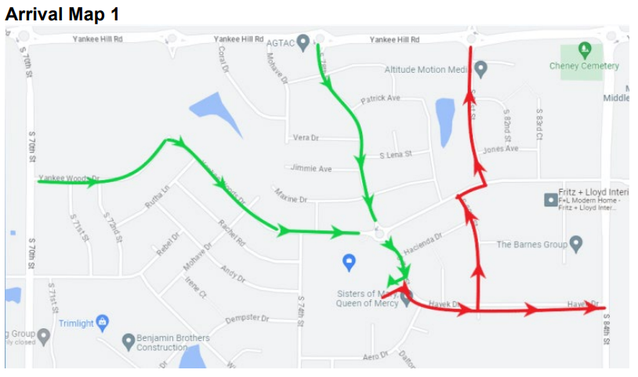
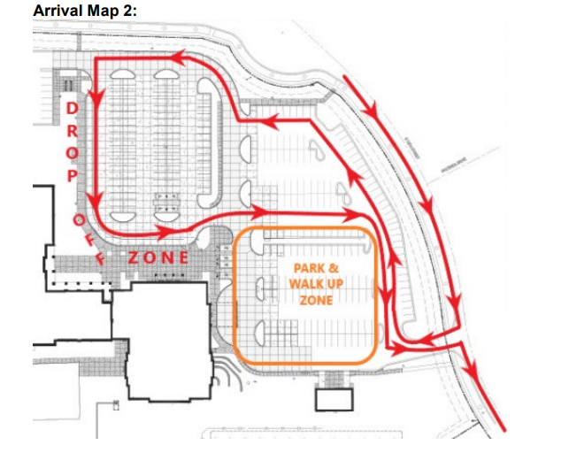

By only entering St. Michael’s property from one direction will prevent road blockages, minimize blind spots, and give residents of the neighborhood a path to get out of the neighborhood in the mornings. Make every effort not to block the roundabout at S 78th St. and Yankee Woods Drive. Look ahead to the S 78th St. roundabout exit before you enter the roundabout to determine whether you should proceed or wait to enter until any backed-up traffic at the exit begins moving. This will aid in keeping traffic flowing through the neighborhood. Lastly, do not block any residential driveways while waiting for arrival or dismissal to begin.
All students arriving after the 8:05 a.m. start bell must report directly to the main office for a late pass before proceeding to class.

Dismissal
Half day students will be dismissed from their classroom by teachers and/or paras at 11am. They will dismiss out the bell tower doors. We ask that parents park in the front loop or front parking lot and come pick up their student. This helps to ensure all students safe arrival to their vehicle.
Full day students will be dismissed from their classroom by teachers at 3:20pm. Upon dismissal, students must leave the school grounds and proceed home or to a previously designated location.
All full day students will be dismissed out the front doors of the school at the end of the day. Classroom teachers will lead students out, then students will proceed to their designated area. Included is a map showing pick-up for lines A and B
Line A: Family Last Names: A-K (north loop)
Line B: Family Last Names: L-Z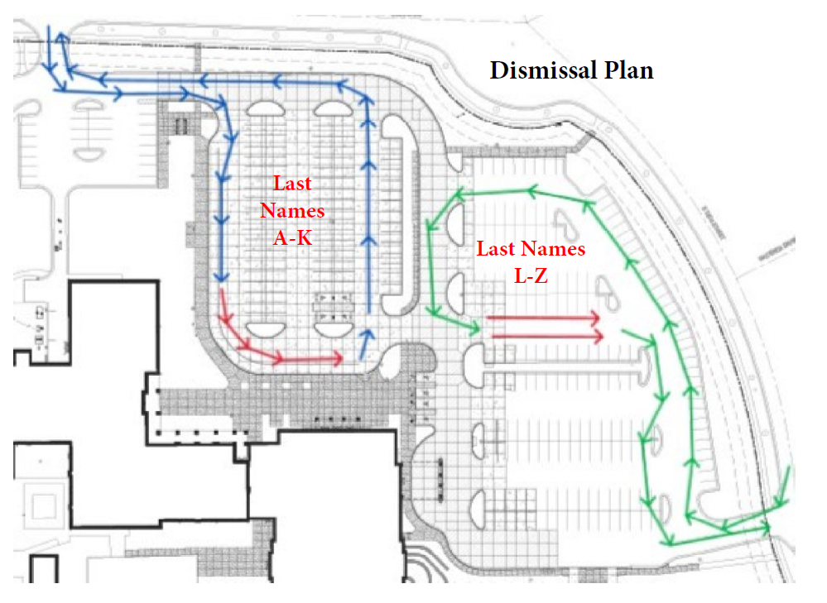
Students attending EDC will be escorted by personnel to the EDC area. Attendance is taken by the EDC personnel and students are expected to follow the rules and procedures outlined by EDC for dismissal from the program.
After 3:30pm, any student remaining on school property, will be brought to the main office. The parent/guardian will be called. Every attempt will be made to contact a parent or person from the approved contact list. If office personnel is unable to contact a parent/guardian or approved contact by 3:45pm the student will go to EDC and the parent will be charged according to EDC policies.
If your student has a change in dismissal plans, please call or email the front office. Any students needing to leave early, will dismiss from the front office.

Sample Daily Schedule
7:45-8:05 | Arrival
8:05-8:55 | Morning work/circle time
8:55-9:25 | Recess
9:30-9:45 | Snack
9:45-10:30 | Center/small group
10:30-11:00 | Music/movement
10:50-11:00 | Handwashing (all day students)
10:55-11:00 | Dismissal (half day students)
11:00-11:35 | Lunch
11:35-12:00 | Bathroom/reading time
12:00-1:15 | Nap/bathroom
1:15-1:40 | Recess
1:45-2:30 | Specials
2:30-3:05 | Snack/centers
3:05-3:15 | Pack-up/dismissal

Meals, Snacks, Specials Classroom Celebrations

Cold Lunch
St. Michael School highly recommends that cold lunch brought by students follow the nutrition guidelines set by the state. Soda pop and energy drinks are not allowed.

Hot Lunch
St. Michael School, provides a daily hot lunch program to all-day Preschool students. A monthly lunch menu is posted on the school website prior to the beginning of each month. Milk (1%) is included with the hot lunch. Due to dietary guidelines provided by the state, preschool students do not receive chocolate milk. Students may purchase a hot meal through the use of the lunch computer system (MySchoolBucks). Parents are welcome to join their child/ren for lunch, please call ahead by 9:30am to inform us that you will be eating at our cafeteria. Milk is also available for those students bringing lunch from home by using the computer system or paying cash.
Prices for hot lunch, seconds and drinks are listed below.
Student Hot Lunch | $3.75
Guest Lunch | $5.00
Milk | $.75

Snack
Preschool students are offered two snacks per day. One snack in the morning and one in the afternoon. All foods offered on the school campus will meet or exceed the USDA Smart Snack in School nutrition standards.
A snack fee will be assessed for each student in Preschool. This fee will take into account students who are half-day and only receive one snack during their time.
If a student has special diet concerns, allergies to foods, dyes, etc., the parent/guardian needs to indicate these issues when completing the PowerSchool Registration. St. Michael School highly recommends a Doctor’s note, outlining the allergies/diet concerns, be turned in to the school office for proper documentation and filling.

Classroom parties
Two classroom parties are scheduled each year: All Saints Day and Christmas. Parties are organized by teachers and room parents and the treats are organized by the school. No other treats are to be brought in during these parties. Other parties must have the permission of the principal before plans are made.

Valentine’s Day
An exchange of Valentines (a treat is allowed) will take place during the school day. We ask that all candy brought in during the exchange be consumed off campus after the students leave for the day and to please make nut free choices when selecting treats and candy.

Birthdays
Birthdays are recognized in the classrooms in various ways. Students may celebrate their birthday/baptismal date by bringing in a sticker, a pencil, an eraser or something educational for each student. Edible treats must be store bought, individually wrapped, and nut free. Students may also donate a book as a gift to the class or library. The book can be labeled with the student's name and birth date inscribed on the first page. The librarian has a list of suggestions available upon request.

Sick Days and Schedule Interruptions

Attendance
The formation of a habit of regular and punctual attendance is important to a student's success in school and in life. Being tardy and or absent from the learning environment is detrimental to a student’s educational process and should be avoided if at all possible. Repeated absences, repeated tardies and truancy is a violation of school rules. The negative results incurred from missing important class time include the lack of interaction in group work, collaboration, teacher direction and class discussions. These essential educational tools cannot be made up or replicated outside the classroom.

Absence
Parents/guardians are asked to email or call (you may leave a message on the answering machine) the office before 9:30 a.m. if their child is absent. If the school is not notified, a call will be made to your home or place of business to check on a student's unaccounted-for absence. It is requested that you specify the cause of absence since the school must submit a weekly school illness report to the Health Department. If a student has been gone for 48 hours or more due to illness, St. Michael School will require medical documentation upon their return to school.

Tardiness
Students are considered tardy if they are not in their classroom by 8:05 a.m. Tardy students must stop in the office to receive a pass. A student will not be marked tardy for icy roads or similar situations.

Repeated Absences and Tardies
Absences and tardies are monitored. When a student reaches 10 absences or 10 tardies, a letter will be sent home to notify parents of the number of absences and/or tardies their child has accumulated. When a student accumulates 15 absences or 15 tardies, the student and his/her parent(s) will be asked to meet with the principal or a person designated by the principal to discuss concerns and develop a plan of action to avoid any more absences or tardies. Should a student reach 20 absences or 20 tardies, a referral to the County Attorney’s Office may be made.

Leaving School Grounds
No student is allowed to leave the school building or premises during school hours without the written request of the parent/guardian. Students, who need to be dismissed early because of illness, appointments, etc., must be picked up in the office. The adult needs to sign the "Sign-Out" book. This procedure is necessary for the safety and protection of the students in school. After dismissal, students should leave the school grounds and go directly home.

Extended Daycare Morning (EDC-AM)
A St. Michael’s staff member will be monitoring early morning daycare where your student/s can be dropped off starting at 7:00 a.m. in the morning. The students will enter through the main doors of our building and remain in the designated EDC room area until it is time for them to move to their classrooms. Students must be registered to attend this program.

Extended Daycare Afternoon (EDC-PM)
A state-approved daycare program provides a safe, healthy and stimulating environment for students after school hours. The program is in operation from 3:20-5:30 p.m. and is managed by St. Michael School. Students must be registered to attend this program. See registration information on the school website.

Doctor and Dental Appointments
Please try to schedule doctor and dental appointments before or after school. If this cannot be done, please send an email to the teacher and front office (stmichaelinfo@cdolinc.net) informing of late arrival or early dismissal.

Vacations
The school calendar is designed in order to provide a few long weekends for families to go on pleasure trips or vacations. Parents are discouraged from removing students from school while classes are in session and are encouraged to plan in conjunction with the school calendar. However, if students will be absent because of family travel, please send a note to school before they leave. Teachers are not required to provide assignments in advance for students leaving school for vacation.

Field Trips
Preschool classes typically participate in two field trips during the school year weather permitting. Typically, we go to Roca Berry Farm in the fall and the Lincoln Children’s Zoo in the spring. Arrangements for field trips will be initiated by your child’s teacher. Field trips should contribute to the educational, cultural, and social growth of the students. Parents will consent to field trip participation by signing the Field Trip Permission Slip that is sent home prior to each field trip. Without consent, students may not participate in the scheduled field trips. We ask that parents who are helping to supervise field trips not bring younger siblings as they may have supervision responsibilities for multiple students.

Behavior Expectations and Discipline
At St. Michael Catholic School, we are committed to fostering a safe, respectful, and nurturing environment where all students can learn and grow in faith. We believe in guiding children with positive reinforcement, clear expectations, and age-appropriate redirection.

Behavior Expectations
Preschool students are expected to:
- Show kindness and respect to peers, teachers, and staff
- Use gentle hands and words when interacting with others
- Follow classroom rules and listen to teacher instructions
- Respect school property and the belongings of others

Behavior Support Procedure
If a student is unable to meet classroom behavior expectations, they will first be asked to move to the Safe Seat located within the classroom to help them regain self-control. If the student is not able to maintain a calm body in the Safe Seat, they will be sent to a Buddy Room for additional support. Should the student continue to struggle with appropriate behavior in the Buddy Room, an Office Referral will be made.

A good rule of thumb: If the behavior is unsafe, seriously hurtful, or cannot be managed safely in the classroom—even with redirection or calming strategies—it may be time to involve the office.

Administrators will inform families when a serious or unsafe behavior has occurred asking parents to partner with them in supporting their child.

Zero Tolerance for Physical Violence
For the safety and well-being of all students, physical violence, aggression, or intentional harm toward others will not be tolerated. This includes, but is not limited to:
- Hitting, kicking, biting, or pushing
- Throwing objects with the intent to harm
- Any behavior that poses a risk to oneself or others

If a child exhibits behavior that endangers themselves, other students, or staff, they will be sent home immediately. Parents will be required to pick up their child as soon as possible. A meeting may be scheduled to discuss next steps and determine if additional support or interventions are needed.

We recognize that young children are still developing self-regulation skills, and our teachers will provide appropriate guidance and support. However, continued unsafe behavior may result in temporary suspension or dismissal from the program if the child is unable to meet behavioral expectations.
By enrolling in our preschool program, parents acknowledge and agree to this behavior policy.

Health and Safety Regulations

Health Records
The school complies with the requirements of the State Department of Health in obtaining and recording health information. The school maintains cumulative health records, screening results and immunizations for each student. All health records and information are used for the purpose of benefiting the student’s educational process and are bound to high standards of confidentiality.

Immunization Records
Immunization records are kept on file in the school health office. Every student in St. Michael School must show evidence of the following immunization protection: 3 doses of DTP, DTaP, DT or Td (diphtheria, tetanus, pertussis), 3 doses of Polio vaccine, 3 doses of Hepatitis B vaccine, 2 doses of MMR or MMRV (measles, mumps, rubella…varicella), 2 doses of varicella or MMRV (2 if given over 13 years of age). Any student who has not met the requirements for immunization under State law must be excluded from school.

Physical Exams
Physical exams by a qualified physician are required within six months prior to kindergarten and seventh grade. Forms must be sent to the school office prior to the beginning of the school year. A physical exam is also required in the case of a transfer from out of state and for 6th, 7th and 8th grade students participating in school sports activities. Students will not be allowed to participate in practices or games until the Physical form has been submitted to the School Athletic Director.

St. Michael School requires all health forms to be turned into the school office prior to the start of the school year. If the required forms are not turned in by the appropriate date, students will be excluded from school until the forms have been submitted.

Dental Exams
All students are required to give the school a record of dental exams annually. Students who do not have record of a dental exam for the year can request a dental screen in the spring.

Health Screening
School health screening tests are given in accordance with the Nebraska State Law. The minimum recommended screening includes: height and weight on all students; audio screening for students in kindergarten and grades 1,2,3 and 6; vision screening for students in kindergarten and grades 1 through 8. Accurate screening and re-screening procedures, identification of problems, referral and follow up are of great importance. Parents are notified in writing when further evaluation is recommended by their health care professional.

Illnesses
Children showing signs or symptoms of contagious or infectious disease are to be kept or sent home. Symptoms of communicable disease include fever, flushed face, headache, muscle or joint aches, nausea or vomiting, diarrhea, convulsions, sore throat, nasal congestion or discharge, unexplained skin eruption, sore or inflamed eyes. Children should not return to school until they have been free of symptoms for at least 24 hours; they should be fever-free WITHOUT fever-reducing medication (Tylenol, etc.) for 24 hours. If a student becomes ill during the school day, he/she will be sent to the health office accompanied by another student. Whenever a student shows symptoms of any contagious or infectious disease or has a temperature of 100 degrees or higher, the parent will be notified immediately and the student sent home. When a child needs to go home because of illness, the parent is asked to pick him/her up as soon as possible because we are not staffed or equipped to care for ill children.

Medication
Any student who is required to take medication during the regular school day must comply with school regulations.
- Non-Prescription Medications – The school will maintain a supply of common non-prescription medications for student use. Parents fill out an “Authorization for Administration of Medication” form granting St. Michael School personnel permission to administer these common non-prescription medications to their student. The student will receive a dose of medication from the school supply when needed. Parents will be notified when their student has been given a non-prescription medication during the school day.
- Prescription Medications – Parents wishing their student to receive a prescription medication during school hours must fill out the “Authorization for Administration of Medication” form and return it to the school health office with the prescription medication in its original container and properly labeled. Each time your child receives a dose of the medication it will be recorded and kept on file. Students with diagnosed diabetes, asthma or other life-threatening conditions are allowed by state law to carry and self-administer prescribed medications if parents have completed and turned in an “Asthma or Anaphylaxis Medication Management Plan” indicating that their child is capable and they prefer he/she self-medicate. For Asthma and Allergy diagnoses, we also need an Action Plan on file for those students who are affected.
All medications, except those that are needed for emergencies (asthma and anaphylactic shock), are stored in a locked cabinet in the health office.

Injury/Accidents
In the case of injury/accident, teachers and/or office staff will offer assistance as needed. If medical attention is necessary, the student’s parent or guardian will be notified. Additionally, the teacher or staff employee who witnessed the injury/accident will fill out an injury report to be kept on file with the school Safety Coordinator. Parents may request a copy of the incident report at any time. All head injuries will have an accident report filled out, and a call to the parent will be made. The student will remain in the office and sit out of any activity until we get a response from the parent. Please make sure that the school has current phone numbers for emergencies. School staff are instructed not to diagnose, nor to treat injuries beyond the basic first aid level. Transportation is the responsibility of the parent. The student will be kept supervised until the parent arrives at school. If a child’s injury requires emergency treatment, the school will first call Emergency Medical Service (911). Parents will then be notified immediately. If the child is taken to an emergency room before the parent arrives, a school staff member will accompany the child. In the event that 911 is called, the parent will be expected to come immediately to the school or to the emergency room. The school will not be held responsible for any incurred costs when emergency personnel must be summoned.

Health Conditions and Special Medical Needs
If your child has a serious health condition or special medical needs - including chronic health conditions (asthma, diabetes, epilepsy, significant physical impairment) or life-threatening allergic reactions (anaphylaxis) - it is absolutely essential that this information be given in writing annually to the Health office and classroom teacher. It is important that the school staff know the care that your child needs and how to provide that care to keep your child safe at school. In order to do this, we need an Action Plan on file for your child. This Action Plan is twofold; one form is filled out by your physician and the other form is filled out by the parent. The Action Plan form can be found at the end of this handbook. If your child uses an inhaler or other medication, either daily or in emergency situations, please be sure that the necessary medication has been sent to the school office. If your child is allowed to self-medicate, St. Michael School requires a “hold harmless” agreement to be on file. All information shared with the Health office and your child’s teacher remains confidential; information is shared on a need-to-know basis with your child’s teachers and other school staff. Unless notified otherwise by a child’s parent, the following protocol will be followed in the event of a life-threatening asthma attack or anaphylactic reaction. This protocol has been mandated for all Nebraska schools by the state legislature.
- Call 911
- Summon designated trained, non-medical staff to implement emergency protocol.
- Check airway patency, breathing, respiratory rate and pulse.
- Administer medications (EpiPen and albuterol) per standing order.
- Determine cause as quickly as possible.
- Monitor vital signs (pulse, respiration, etc)
- Contact parents immediately and physician as soon as possible.
- Any individual treated for symptoms with epinephrine at school will be transferred to a medical facility.

Lice
Parents are asked to call the school office if their child has lice. If a student is suspected of having lice, he/she will be checked. If lice or nits (lice eggs) are found in the child’s hair, the child is sent home. The child may return to school the next day after the first treatment. Upon returning to school, the child will be checked in the health office for lice/nits. St. Michael office personnel may check the hair of siblings, but we will not check the entire class. Parents with children in the class of a child affected by lice will be notified, in order to prevent further spread. Information and guidelines on how to check for and treat lice are available in the Health office.

School Safety and Security
St. Michael School is committed to providing a safe environment for students, staff and visitors. We work with safety officials to ensure that our school is well prepared in the event of an emergency and conduct drills throughout the school year to help students and staff prepare for possible emergencies.

Child-to-Staff Ratio
In accordance with Nebraska state licensing guidelines, we maintain the following child-to-staff ratios in our preschool classrooms:
- Three-Year-Old Classroom: 1 staff member for every 10 children
- Four-and Five-Year-Old Classrooms: 1 staff member for every 12 children
These ratios ensure that each child receives the attention and support necessary for their growth, learning, and well-being. Additional staff may be present in the classroom to support instruction, supervision, and individual student needs.

Entrances and Exits
All doors entering and exiting the building, including the main entrance after 8:15 a.m. remain locked throughout the day. Parents/visitors wishing to enter the school must come through the main entrance. All parents/visitors must sign in at the office and secure and wear a visitor pass so that faculty and staff know that you have checked in at the office.

Safety Procedures/Drills
Fire Procedure
Ten fire drills are conducted throughout the year at different times of the school day. Students are given directions for fire drills at the beginning of each school year.

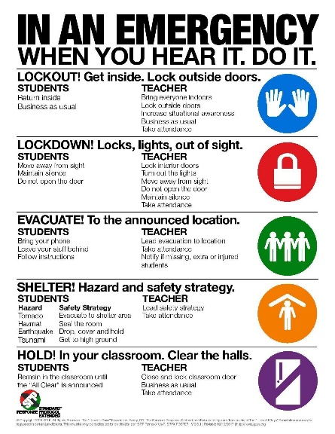
Tornado Procedure
In the spring, prior to the tornado season, students are shown what to do in the event of a tornado, and practice the drill.

Hold
A Hold is followed by the Directive: “In Your Room or Area” and is the protocol used when the hallways need to be cleared of occupants for any reason.

Secure
A Secure is followed by the Directive: “Get Inside. Lock Outside Doors” and is the protocol used to safeguard people within the building.

Lock Down Procedures
A Lock Down is followed by “Locks, Lights, Out of Sight” and takes place if an internal threat is identified at the school. This could mean that doors within the school are locked down and that the students go into silent mode. It could also mean that students who are able to walk out of the building to get out in a safe manner, might walk out instead of being locked down. Lock Down drills are conducted once a semester so that students know what to do in case of danger in the building.

Evacuate
This may be followed by a location, and is used to move people from one location to a different location in or out of the building. In the event of certain building emergencies (actual fire, bomb threat, etc.), students are relocated to our evacuation site. When students are evacuated, we ask that parents not intercept and take students on their way to that location. For student safety, we need to make sure that all students reach the safe location and are dismissed to parents in a safe and orderly fashion.

Reunification
Parents will be directed by St. Michael email or public safety officials via media to their child’s specific location. Students will be released only to parents or those who are documented as emergency contacts in PowerSchool. During reunification, students will be released to parents/emergency contacts after presenting a picture ID such as a driver’s license, military ID or passport.

Parent Directives in Emergency Situations

BE PREPARED FOR A SCHOOL EMERGENCY
- Be sure that your child’s emergency contact information is always accurate and current.
- Speak with your child about basic personal safety and safety procedures at school.

IN CASE OF A SCHOOL EMERGENCY
- DO NOT call or rush to your child’s school. Phone lines and staff are needed for emergency response efforts.
- DO NOT phone your child. Staff and students are not to use cell phone communication during an emergency, for safety reasons.
- Cooperate fully with staff, emergency or law personnel on the scene.

FOLLOWING AN EMERGENCY
- Listen to and acknowledge your child’s concerns.
- Provide reassurance that your child is safe.
- Assure your child that additional prevention efforts are being put into place.
- Seek help from school personnel or a mental health professional if concerns persist.

Child Abuse or Neglect
Abuse or neglect is knowingly, intentionally or negligently causing or permitting a minor to be placed in a situation that endangers his or her mental health; cruelly confined or cruelly punished; deprived of necessary food, clothing, shelter or care; left unattended in a motor vehicle if six years of age or younger; sexually abused or sexually exploited. Nebraska law mandates that when any person has reasonable cause to believe that a child has been subjected to abuse or neglect or has observed such a child being subjected to conditions or circumstances which reasonably would result in abuse or neglect, the person shall report such an incident or cause a report to be made to the proper law enforcement agency or to the Nebraska Department of Social Services (1-800-652-1999).

Asbestos Hazard Emergency Response Act
In accordance with the Environmental Protection Agency regulations, St. Michael School is in compliance with all rules and regulations regarding Asbestos.

Emergency Classroom Communication
Each classroom has a call button to use in emergencies: when the teacher suddenly becomes ill; when a student becomes ill; when a student is exhibiting extreme and potentially dangerous behaviors; when a stranger is present in the building.

School Family Communication and Involvement
Parent-Teacher Meetings
Preschool families can expect to meet with teachers during scheduled parent-teacher conferences in February and as needed throughout the school year. Additionally, progress reports are sent home three times per year—in the fall, winter, and spring.
What to Expect at a Parent-Teacher Conference
Conferences include a review of your child’s most recent assessments in areas such as letter recognition, numeral recognition, counting, color identification, and shapes. Teachers will also share “glows” (your child’s strengths) and “grows” (areas for development at home). This is also a great time for families to ask questions or discuss concerns.
Routine Communication
Preschool teachers send home a weekly newsletter with updates on classroom themes, important dates, and upcoming activities.
Family Involvement Opportunities
St. Michael Catholic School encourages parent involvement through various opportunities:
- Our Parent Ambassador Program includes a class representative who helps coordinate family engagement and volunteer opportunities (e.g., class parties, donation needs).
- Field trip support is especially appreciated in the fall and spring, when parent drivers and chaperones are needed.
- Volunteering at class events or participating in school-wide activities is always welcome!
Visiting During School Hours
Parents are welcome to visit during lunch or volunteer at class events:
- If you plan to join your child for lunch, please notify the teacher and school office in advance.
- Class party participation is another fun way to spend time with your child during school hours.
Contacting Your Child’s Teacher
For non-emergency questions, comments, or concerns, email is the preferred method of communication. Please allow 24 hours for a response, as teachers have limited access to email during the school day. For urgent matters, contact the school office directly.

Tuition, Fees, and Billing Policies

Tuition
3-Year-Old Program
- Monday through Friday, All Day: $6,950
- Monday through Friday, Half Day: $4,175
- Monday/Wednesday/Friday, Half Day: $4,175
4-5-Year-Old Program
- Monday through Friday, All Day: $6,450
- Monday through Friday, Half Day: $3,875
- Monday/Wednesday/Friday, Half Day: $3,225

Additional Fees & Payment Information
Preschool Snack Fee (Snack fee is due before the start of the school year)
- Monday through Friday (All Day): $180
- Monday through Friday (Half Day): $90
- Monday/Wednesday/Friday (Half Day): $50
Preschool/Prekindergarten Registration Fee (Due at time of enrollment)
- $50 (Non-Refundable)

Tuition Payment Options
- Tuition may be paid in full or over a 10-month period.
- If paying over the 10-month period, an ACH form must be completed and submitted to the school office before the start of the school year.

Required Documents
The following forms must be submitted to the school office before the start of the school year:
- Birth Certificate
- Baptismal Certificate
- Immunization Record

Preschool & Prekindergarten Acknowledgment and Signature
_________________________________________________
Printed Name (Parent/Legal Guardian)
_________________________________________________ ________________________
Signature (Parent/Legal Guardian) Date

